Soru-1

**i-) S**

**a S**

**X**

**a X a**

**a**

**ii-) S**

**aS aSb X**

**aaS aaSb aX aaSb aaSbb aXb aXa a**

**aaaS aaaSb aaX**

**aaaSb aaaSbb aaXb aaXa aa aaaSb aaaSbb aaXb aaaSbb aaaSbbb aaXbb aaXab aab aaXaa aaa**

**\*Sondaki tüm elemanların altında ... olacak ama düzeni ayarlayamadım.**

**iii-)**

S → aS | aSb | X

X → aXa | a

Step-1 (Nullable yok.)

Step-2:Remove unit production

S → aS | aSb | aXa | a

X → aXa | a

Step-3:

A→a

B→b

S→AS | ASB | AXA| a

X→AXA | a

Step 3 cont.:

A→a

B→b

R1→SB

R2→AX

S→AS | AR1 | R2A | a

X→ R2A | a

Soru-2



**i-)**

S→ aXa

X→ aXa | Y

Y→ b | bY | Yb

**ii-) *Accept dışı tüm durumlar Reject’e gider.**

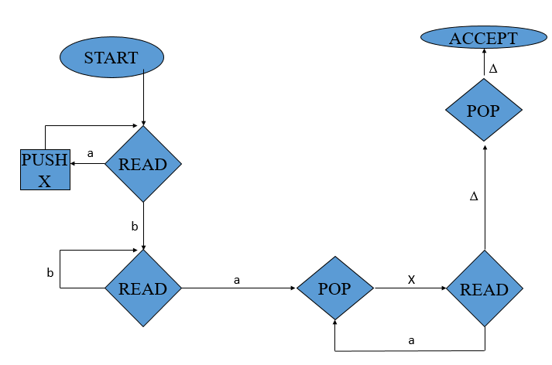

**iii-)**

S→ aXa

X→ aXa | Y

Y→ b | bY | Yb

İstenen:: aaaabbbaaaa

S => aXa => aaXaa => aaaXaaa =>aaaaXaaaa => aaaaYaaaa => aaaabYaaaa =>

aaaabbYaaaa => aaaabbbaaaa

**iv-)**

S→ aXa

X→ aXa | Y

Y→ b | bY | Yb

İstenen:: aaaabbbaaaa

**S**

**a X a**

**a X a**

**a X a**

**a a**

**Y**

**b Y**

**b Y**

**b**